**NNFL EXPT-4A**

**Fuzzy Controller for Edge detection in an image**

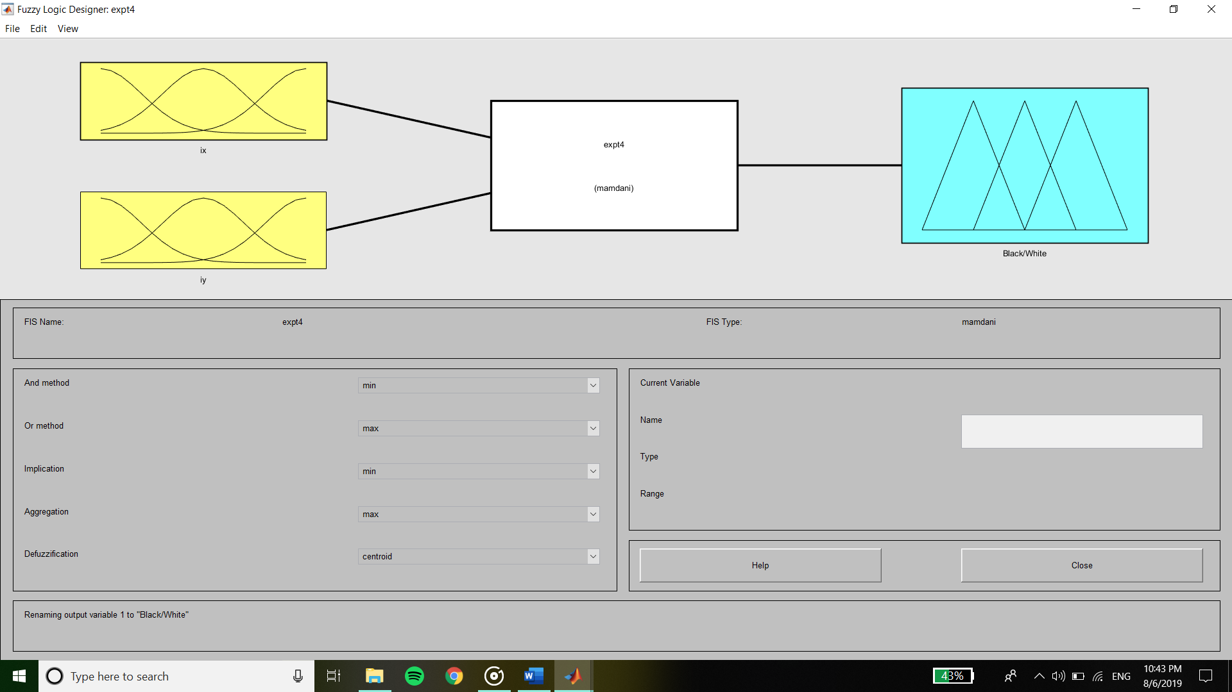

**Inputs :**

**Membership Function of Gradient-X (ix)**

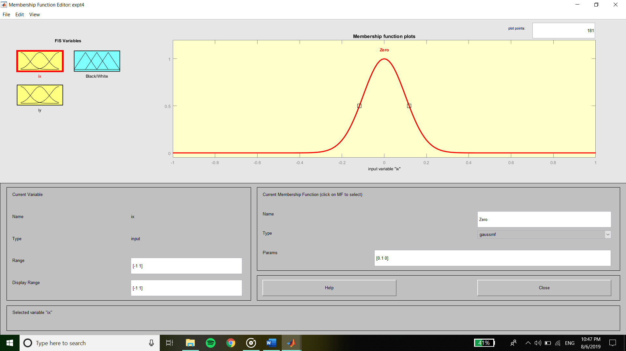

**Membership Function of Gradient-Y (iy)**

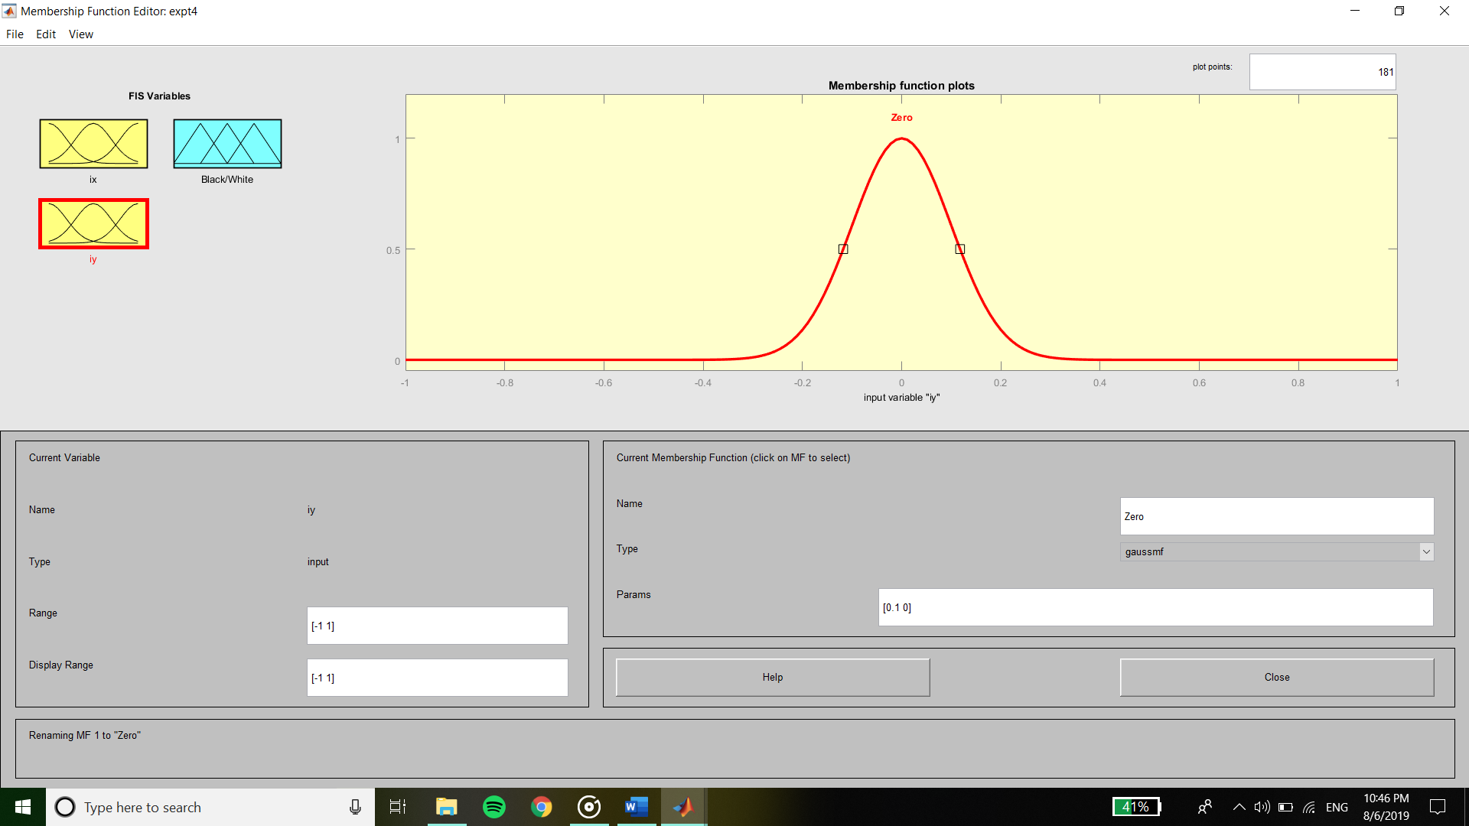

**Output :**

**Membership Function of Output**

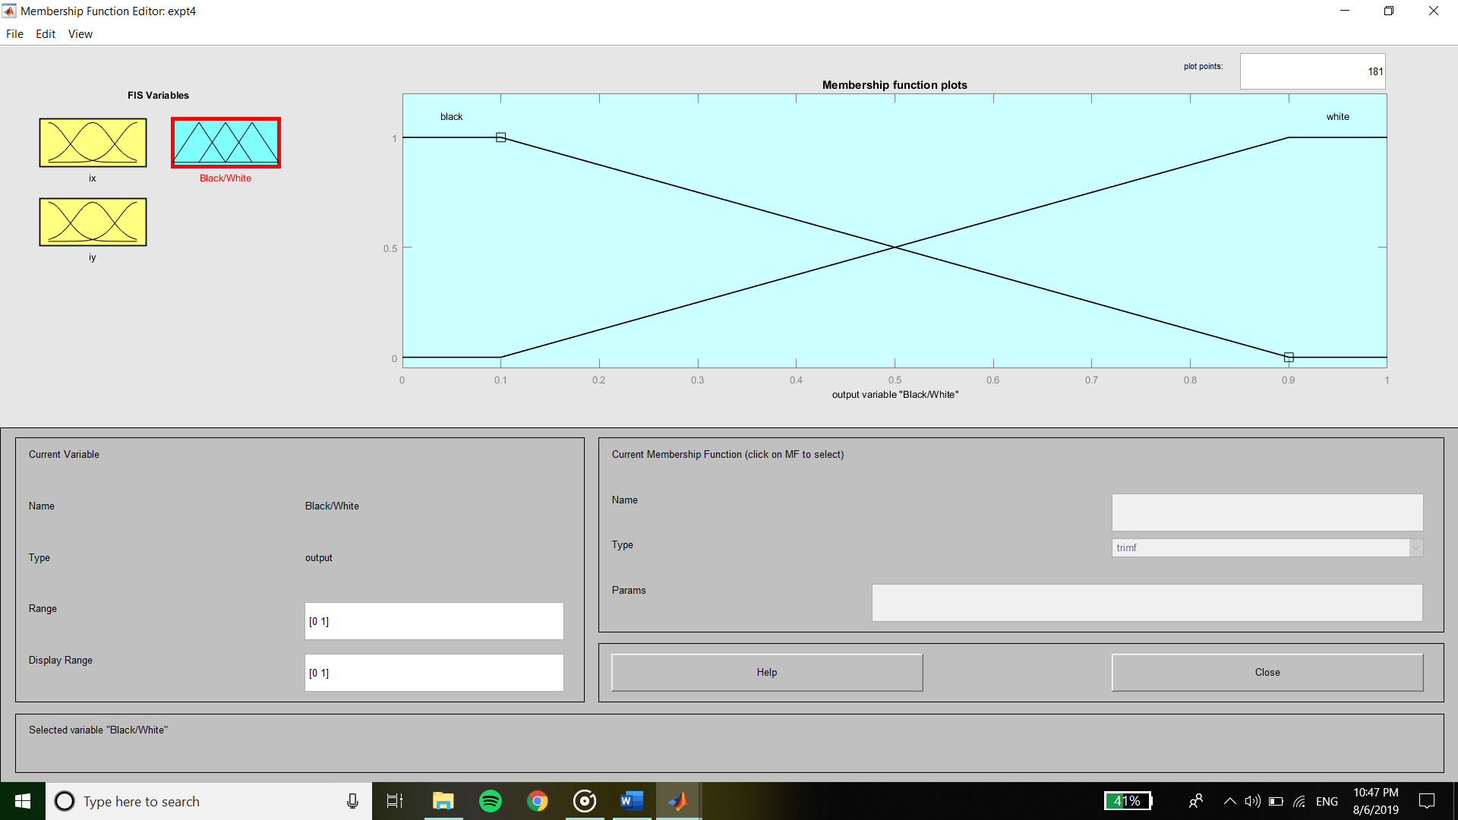

**Rule Base**

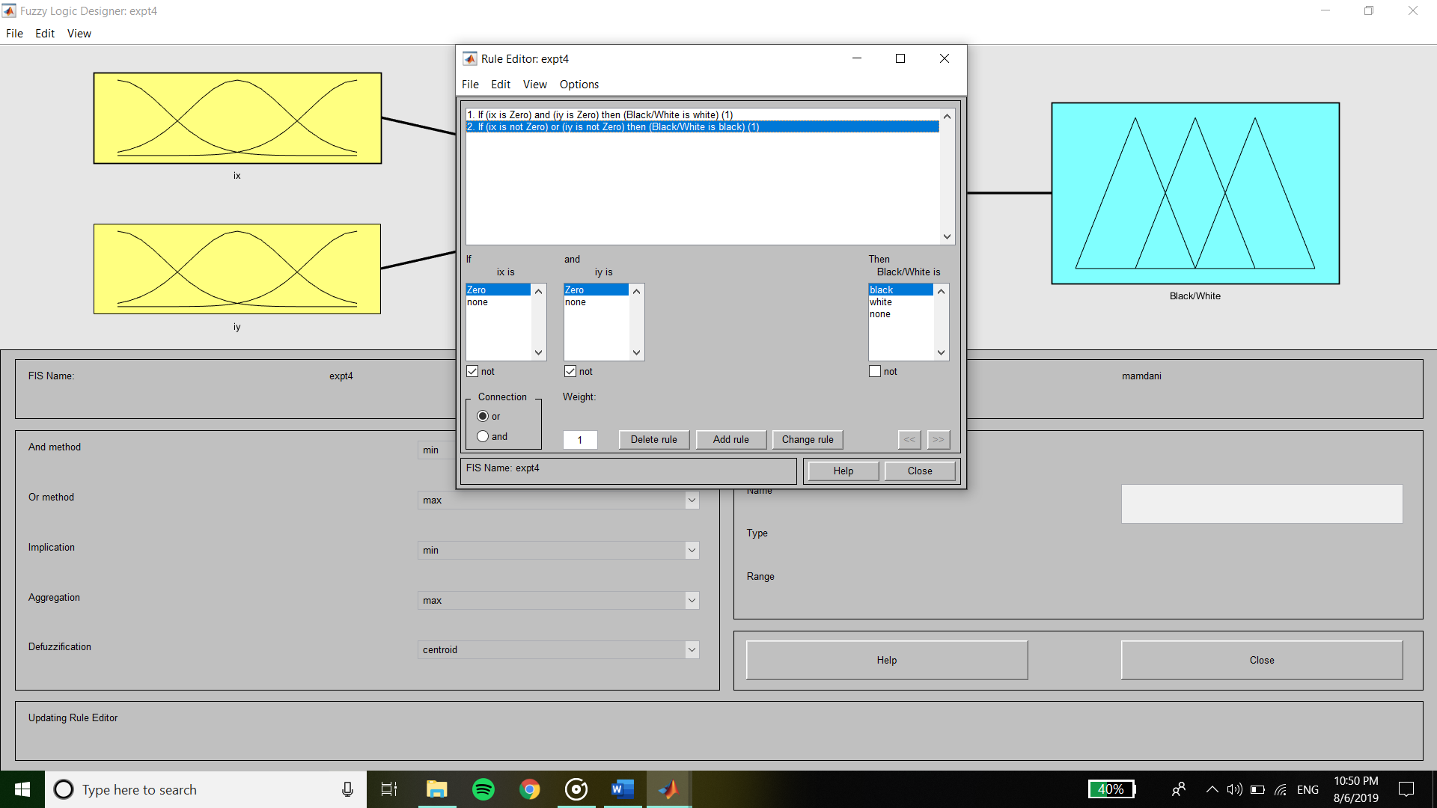

**Code :**

clc

clear all

close all

img=im2double(rgb2gray(imread('peppers.png')));

img = imresize(img,[256 256]);

a=max(max(img));

b=min(min(img));

img_norm=(img-b)/(a-b);

gx=[-1 1];

gy=gx';

Ix=conv2(img_norm,gx);

Iy=conv2(img_norm,gy);

fis1=readfis('expt4');

getfis(fis1);

showrule(fis1);

for i=1:256

for j=1:256

Ieval(i,j)=evalfis([Ix(i,j); Iy(i,j)]',fis1);

end

end

figure(1)

subplot(2,2,1)

imshow(img)

title('Original Image')

subplot(2,2,2)

imshow(Ix)

title('Gradient-X Image')

subplot(2,2,3)

imshow(Iy)

title('Gradient-Y Image')

subplot(2,2,4)

imshow(Ieval)

title('Edge-Detected Image')

**Output :**

  